Cardiovascular Impact of Race and Ethnicity in Patients With Diabetes and Obesity: JACC Focus Seminar
Prakash Deedwania MD,FACC,FAHA,FESC,FHFSA
Professor Of Medicine ,UCSF School of Medicine,SanFrancisco,CA

Obesity and type 2 diabetes mellitus are highly prevalent and increasing in the United States among racial/ethnic minority groups. Type 2 diabetes mellitus, which is driven by many factors including elevated levels of adiposity, is an exemplar health disparities disease. Pervasive disparities exist at every level from risk factors through outcomes for U.S. racial/ethnic minority groups, including African American, Hispanic/LatinX American, and Asian American populations. Disparities in clinical care exist including hemoglobin A1c control, lower prescription rates of newer antihyperglycemic medications, along with greater rates of complications postbariatric surgery. Underpinning these disparities are the social determinants of health affecting provider–patient interactions, access to resources, and healthy built environments. We review the best practices to address cardiometabolic disparities in the current cardiovascular guidelines and describe recommendations for cross-cutting strategies to advance equity in obesity and type 2 diabetes across U.S. racial/ethnic groups.
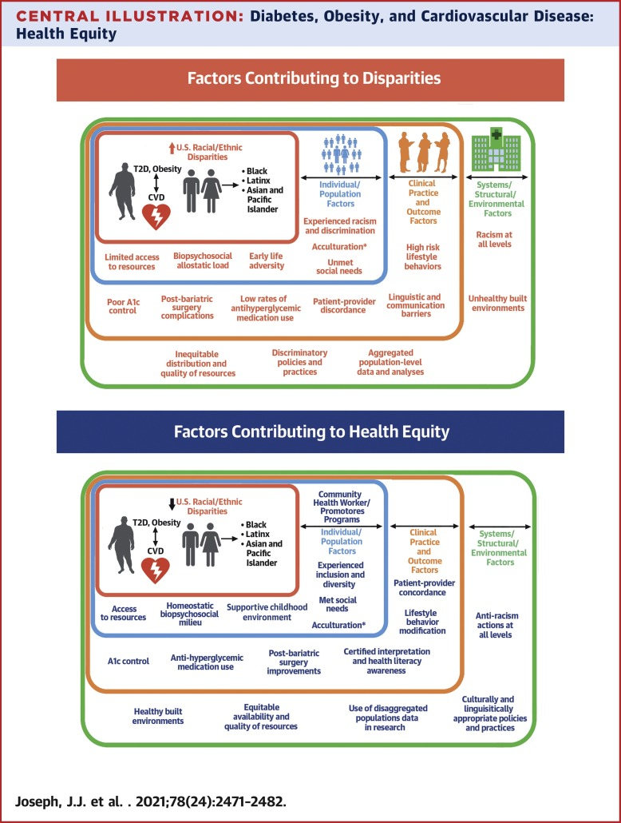

Racial/Ethnic Disparities in Epidemiology
In the United States, NHB populations have the highest prevalence of obesity (49.6%) followed by Hispanic/LatinX (44.8%), non-Hispanic White (NHWs) (42.2%), and Non-Hispanic Asian American (17.4%) populations (1). Severe obesity (BMI ≥40 kg/m²) prevalence is highest in NHB (13.8%), followed by NHW (9.3%), Hispanic/LatinX (7.9%), and Asian American (2.0%) populations . The rates of obesity and severe obesity are rising in all populations, with the higher diabetes prevalence in Asian American,
Racial/Ethnic Disparities in Clinical Care
NHB populations have worse diabetes control using hemoglobin A1c (A1c) as a marker of glycemia compared with NHW populations. The impact of access to routine care and insurance have been reviewed and show important findings. Although large observational studies in NHB populations with diabetes are nonexistent, multiracial studies in patients without diabetes show a higher risk of CVD per increase in A1c with no difference between NHB and NHW groups (27).
Behavioral modification, including physical activity, nutrition, stress management, etc, are key to modification of obesity, diabetes, and CVD. The multiethnic Look AHEAD (Action for Health in Diabetes) randomized controlled trial did not show a major adverse cardiovascular event (MACE) benefit from increased physical activity in patients with diabetes, although it did show positive non-CVD outcomes.
Fundamental Causes of Disparities in Obesity and T2D From Patient and Provider Perspectives
The fundamental causes of undertreatment and poor control in U.S. racial/ethnic minority groups are multifaceted, but include acculturation, concordance (linguistic, cultural, and racial), and SDoH. Acculturation is the process by which new cultural elements and engagement in specific behaviors are acquired, including the lifestyle, diet, beliefs, and values of a new country. U.S.acculturation in Hispanic/LatinX populations is associated with obesity-related behaviors, obesity, and diabetes.

Public Health Measures to Improve impact of Race and Ethnicity
Approaches to improving obesity, diabetes, and CVD must address SDoH through multilevel approaches focusing on nonmedical, health-related social needs (ie, approaches to improve food insecurity have shown reductions in A1c) and/or by addressing the SDoH through policy (ie, poverty, racism, residential segregation) . Policy reform will have long-lasting impacts through deconstructing the systems leading to SDoH-based inequities.
Conclusions
Obesity and T2D are exemplar health disparity conditions caused by inequities across the spectrum of the diseases. U.S. racial/ethnic minority groups are significantly affected by the deleterious impact of obesity and diabetes on CVD. Currently, building trust with patients, effective communication, diversity in medicine and science, and patient-centered, guideline-based care are cornerstones of improving diabetes and obesity care. Further research is needed to address several topics.

